INTRODUCTORY DIVERS

Frank briefing introductory divers at Casino Point Dive Park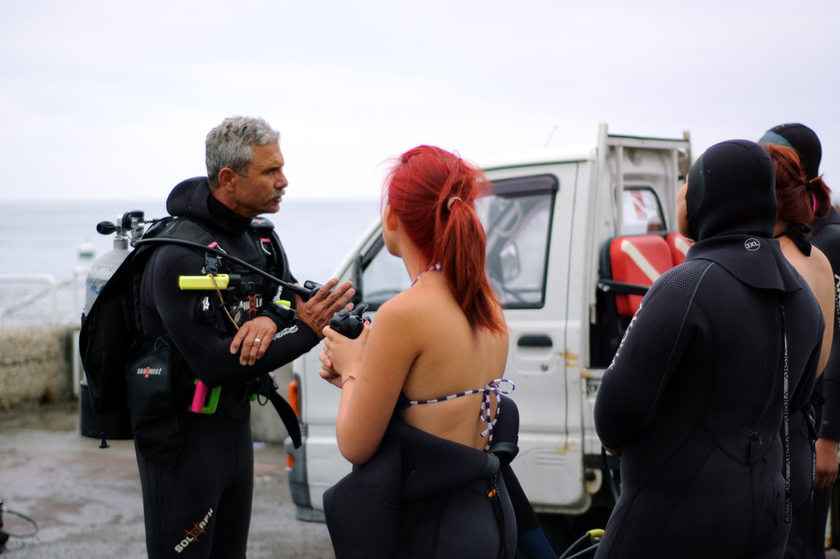



Ron double checking gear on introductory diver at Casino Point



Introductory dive students back at the shop

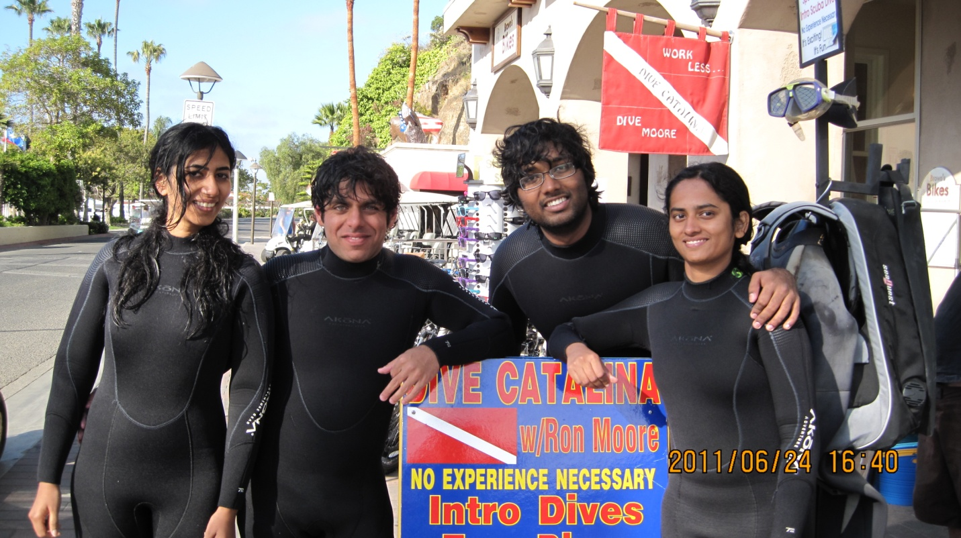

After first dive, excited students posing with Ron

I

12 year old first time diver on dive steps after completing introductory dive

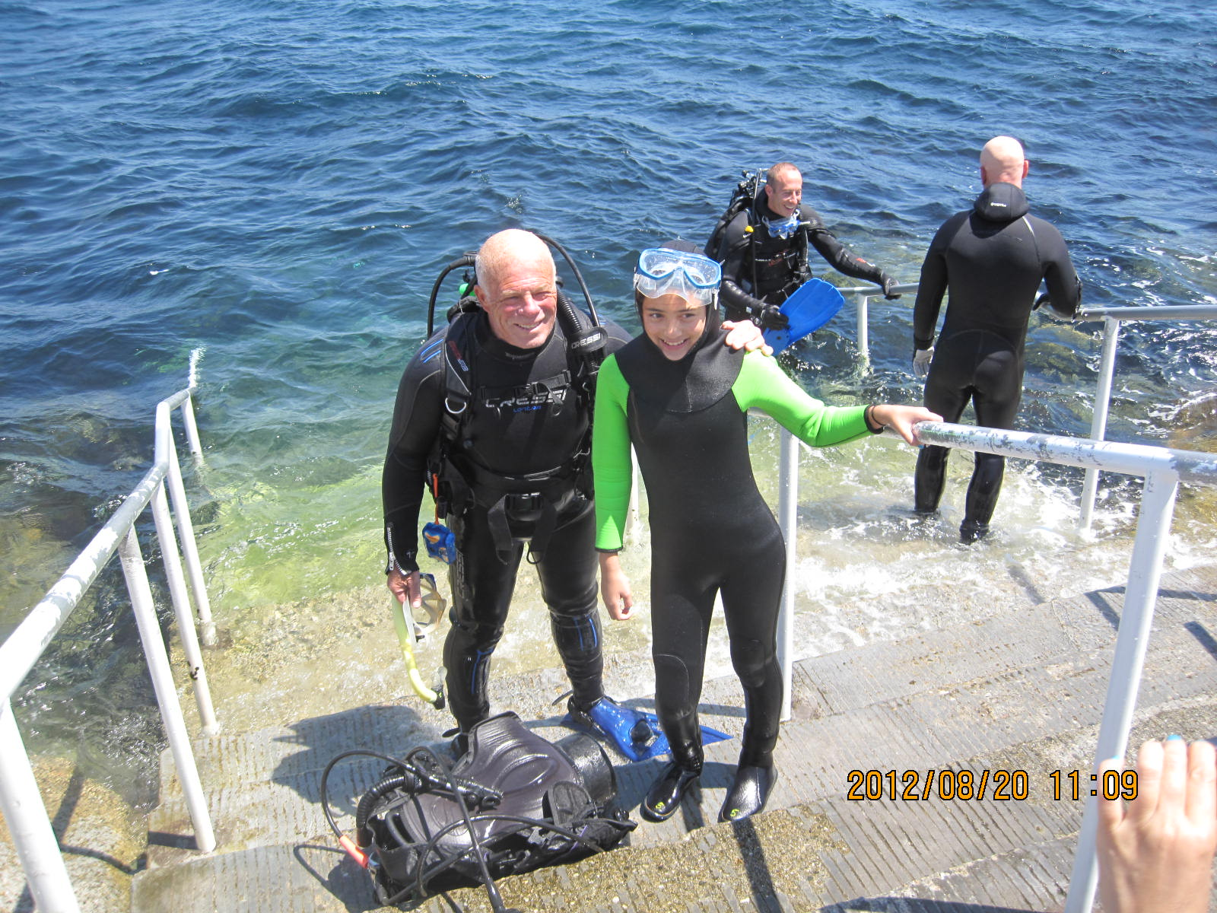

Students proudly posing after introductory dive at Casino Point Dive Park

